**Low back pain**

**Initial Assessment**

|  |  |  |
| --- | --- | --- |
| **Presenting Symptom/Chief Complaint** | | |
| Acute pain. Back obstruction syndrome due to sprain and cold. | | |
| **Main Signs and Symptoms** | | |
| Back pain, stiffness of the back muscles due to weightlifting, aggravated by cold wind. | | |
| **Other Signs and Symptoms** | | |
| No sciatica. Acute sprain of low back pain with stagnation of the QI. | | |
| **TCM Diagnosis and Treatment (identified TCM disease, TCM differentiation of syndromes)** | | |
| Acute back pain (back obstruction syndrome) due to sprain of the back muscle. QI stagnation and cold invasion. | | |
| **Treatment Principles and Strategies** | | |
| Remove muscle sprain, eliminate windincrease of QI movement. | | |
| **Treatment Plan (Modalities; acupuncture, herbal, dietary, manual therapies), frequency and duration** | | |
| Acupuncture: Distal points with reduction method + local point’s tonification two times a week 1 hour. Combination of source + back SHU points. | | |
| **Any other Advice Given to Patients** | | |
| Acupuncture: UB 26 (bilateral), UB 23 (bilateral), Shigizhuixia, Jao Yan(L4-L5)  Distal points with reduction UB 60 (bilateral) UB 40, UB62, K4 (bilateral) | | |
| **Practitioner:** | **Date:** | **Signature:** |

**Daily Charting____________________________________Patient Name:**

**Date:**

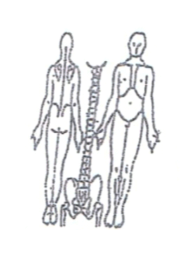 **Working Diagnosis:** Acute pain, back obstruction syndrome

due to sprain of the back muscle. QI stagnation.

S: Acute back pain after weightlifting aggravated by cold. Sleep ↓ ROM ↓,

Movement ↓.

O:

Treatment (P) Acupuncture: UB 26 (bilateral), UB 23 (bilateral), Shigizhuixia, Jao Yan(L4-L5). Distal points with reduction UB 60 (bilateral) UB 40, UB62, K4 (bilateral)

(A) Acupuncture only with distal points. Seduction (15 minutes) +

tonification of local points.

**Date:**

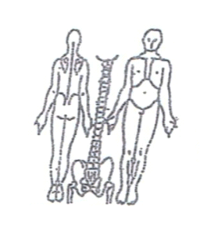**Working Diagnosis:**

S: Symptoms the same, getting worse with movement. Sleep ↓, Rom ↓.

O:

Treatment (P) Acupuncture with warm up needles for 1 hour according to protocol

(A)

**Date: _______________**

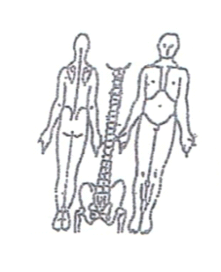**Working Diagnosis:**

S: Symptoms better. Pain 2-3 of the scale. Sleep better.

O:

Treatment (P) Acupuncture 1 hour + Moxibustion.

(A)

**Date:_ _______________**

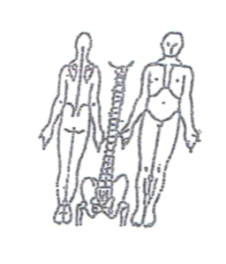**Working Diagnosis:**

S: N movement. Pain 1-2 of scale. N Rom. N sleep.

O:

Treatment (P) Acupuncture 1 hour + stretching exercises.

(A)

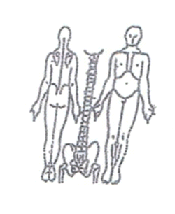**Date:_ _______________**

**Working Diagnosis:**

S: No symptoms. No pain. N movement. N sleep.

O:

Treatment (P) Acupuncture 1 hour due to the protocol.

(A)